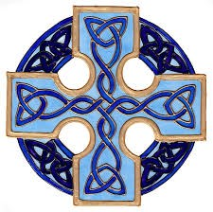
Plwyfi Bro Ystwyth a Mynach Bro Ystwyth & Mynach Parishes

NOVEMBER 2016 SERVICES / GWASANAETHAU TACHWEDD

Sunday 6 November
Llanafan | 09:45 | Holy Communion / Cymun Bendigaid
Llantrisant | 10.30 | Holy Communion / Cymun Bendigaid (Grwp Mynach Group)
Ysbyty Cynfyn | 2.30pm | Evening Prayer (All Souls Service)

Sunday 13 November
Llanafan | 10.00 | Remembrance Service
Mynach Chapel | 10.00 | Remembrance Service
Ysbyty Ystwyth | 10.00 | Remembrance Service
Ysbyty Ystwyth | 4.00pm | Taize Style service

Sunday 20 November
Llanafan | 9.45 | Holy Communion / Cymun Bendigaid
Llanfihangel | 11.15 | Holy Communion / Cymun Bendigaid
Ysbyty Cynfyn | 10.30 | Holy Communion / Cymun Bendigaid (Grwp Mynach Group)

Sunday 27 November
Ysbyty Ystwyth | 11.00 | Holy Communion / Cymun Bendigaid
Llanfihangel | 11.15 | Holy Communion / Cymun Bendigaid
Llantrisant | 10.30 | Holy Communion / Cymun Bendigaid (Grwp Mynach Group)
Llanafan | 5.00pm | Plygain

Midweek Holy Communion is held every Wednesday at 11.00 am at Ysgoldy Goch, Cwmystwyth

